Inter Unit Posting

Transaction Code FB50

ACCESS PATH SAP Easy Access → Accounting → FinancialAccounting→
General Ledger → Document Entry → GL Account Posting

We get G/L Account Posting Screen as under
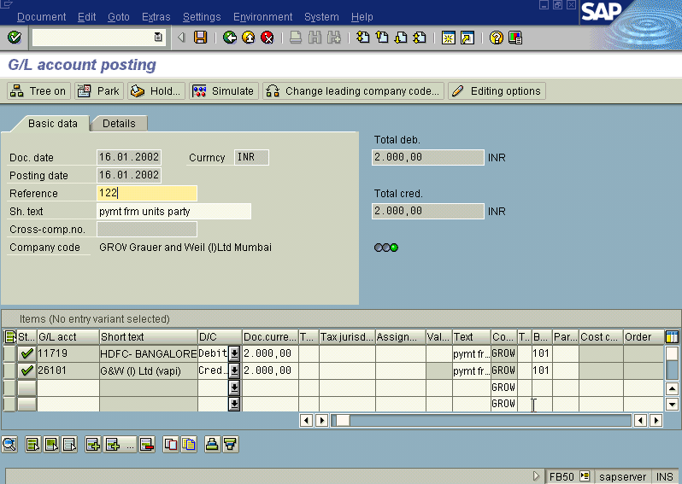

Press Enter

The System will show 2 Green ticks near the G/L Accounts

Press Post

The System posts the document and generates the Accounting Document. Take note of the Accounting Document generated eg: 100116.

To display the Accounting Document generated

Select Document → Display. The System displays the screen as Under

